The Machine Learning Canvas (v0.4) Designed for: Designed by: Date: Iteration: .
  Decisions  How are predictions used to make decisions that provide the proposed value to the end-user? |   ML task  Input, output to predict, type of problem. |   Value Propositions  What are we trying to do for the end-user(s) of the predictive system? What objectives are we serving? | 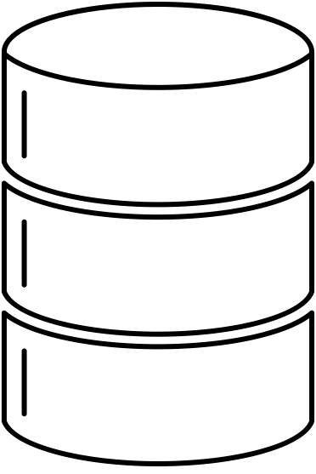  Data Sources  Which raw data sources can we use (internal and external)? | 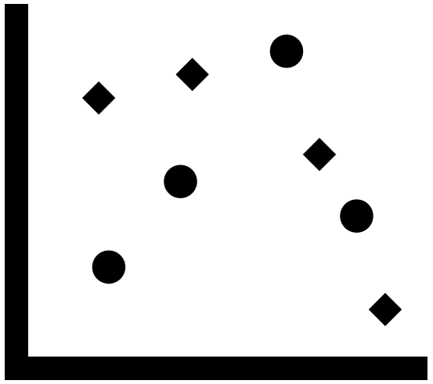  Collecting Data  How do we get new data to learn from (inputs and outputs)?
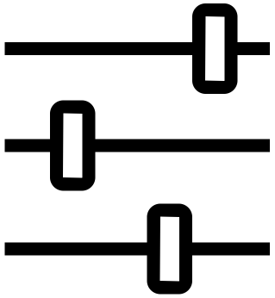  Making Predictions  When do we make predictions on new inputs? How long do we have to featurize a new input and make a prediction? |   Offline Evaluation  Methods and metrics to evaluate the system before deployment. |  |   Features  Input representations extracted from raw data sources. |   Building Models  When do we create/update models with new training data? How long do we have to featurize training inputs and create a model?
 | Live Evaluation and Monitoring  Methods and metrics to evaluate the system after deployment, and to quantify value creation. |  | 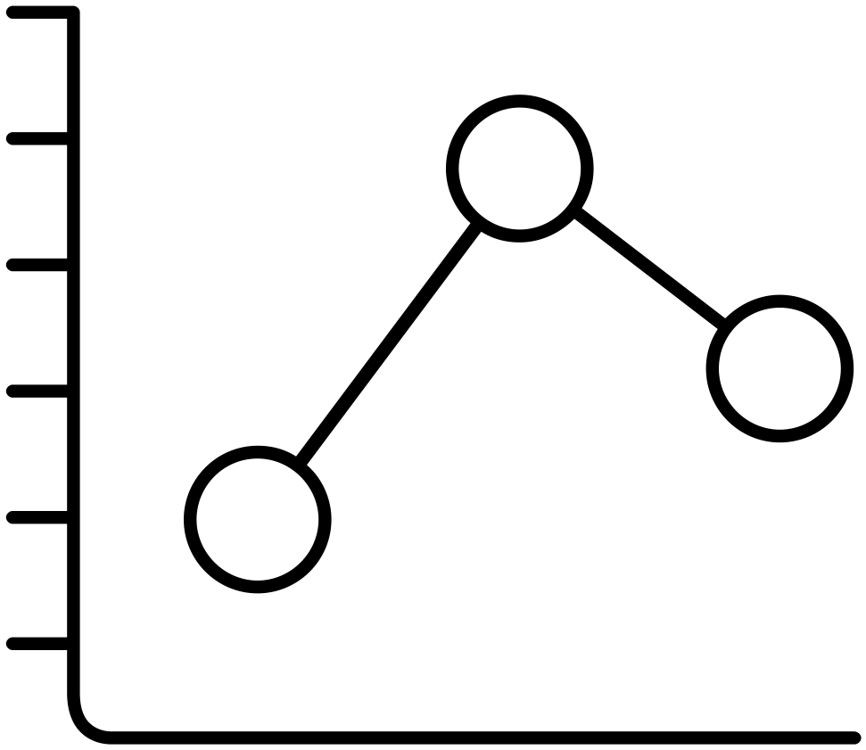
machinelearningcanvas.com by Louis Dorard, Ph.D. Licensed under a Creative Commons Attribution-ShareAlike 4.0 International License.

